1 This project involves the Adafruit Capacitive Touch HAT to have a bit of fun you’re your Pi. The HAT has 12 capacitive touch sensors to which you can attach electrodes.

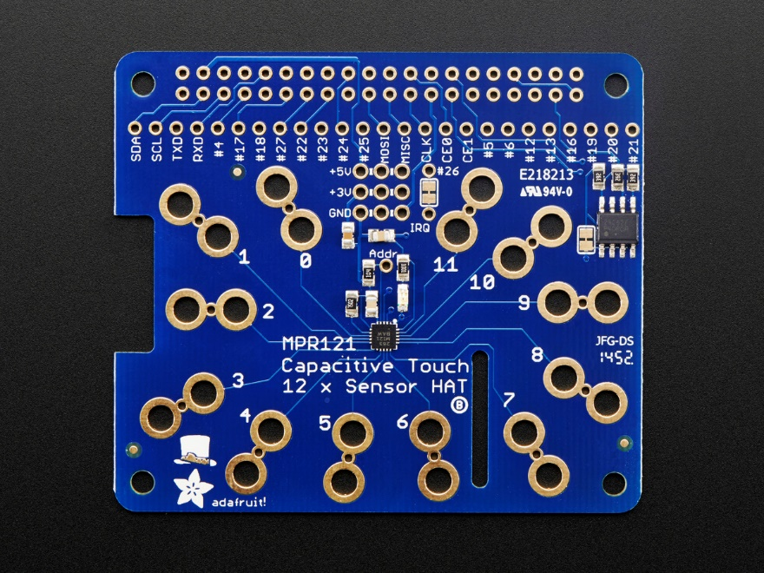

2 The HAT simply plugs onto your A+/B Pi allowing you to plug in electrodes which can then be attached to objects that conduct electricity.

s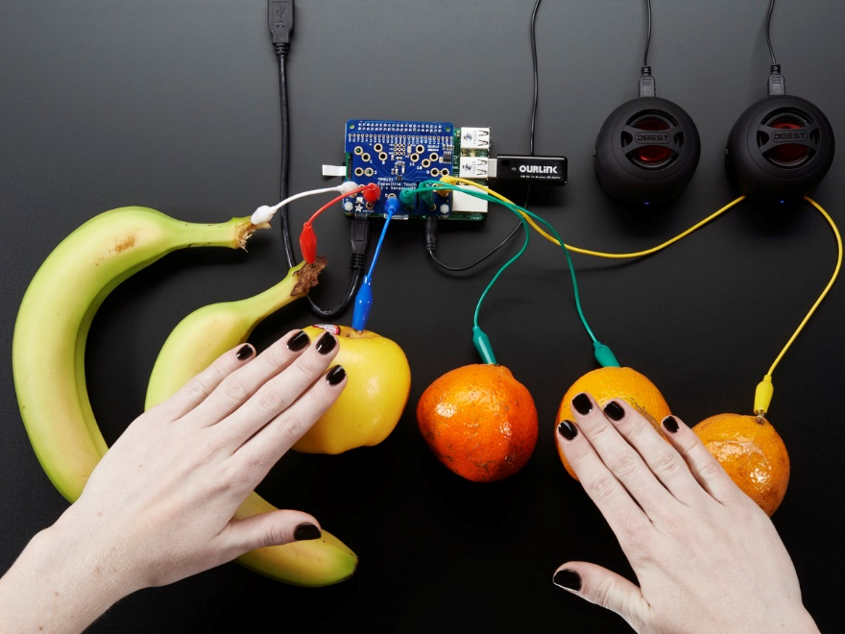

3 You need to enable i2C on our Pi using raspi-config

[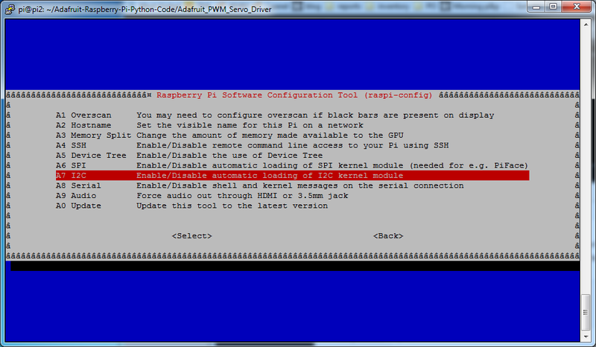](https://learn.adafruit.com/assets/22832)

4 Then install some software onto your Pi

$ sudo apt-get install build-essential python-dev python-smbus python-pip git

$ cd ~

$ git clone <https://github.com/adafruit/Adafruit_Python_MPR121.git>

$ cd Adafruit_Python_MPR121

$ sudo python setup.py install

5 Then test to see if it works

$ cd examples

$ sudo python simpletest.py

6 Make some noise!

$ sudo python playtest.py

Now try changing the sounds around (check out other samples in /opt/sonic-pi/etc/samples)

More information on how to complete this project is at:

<https://www.raspberrypi.org/documentation/hardware/raspberrypi/spi/README.md>

<http://fuenteabierta.teubi.co/2013/07/utilizando-el-lector-nfc-rc522-en-la.html>